IN HOUSE PAPER REPORT

ON

**MAKING CHATBOT USING PYTHON**



In partial fulfillment of the requirements of the degree of

**BACHELOR OF TECHNOLOGY**

IN

**COMPUTER SCIENCE AND ENGINEERING**

**BY- SURVEPALLI SREEKRUTI A2305220266**

UNDER THE GUIDELINES OF

**DR. JUHI SINGH**

**DEPARTMENT OF COMPUTER SCIENCE AND ENGINEERING**

**AMITY SCHOOL OF ENGINEERING AND TECHNOLOGY**

**AMITY UNIVERSITY, UTTAR PRADESH.**

**Declaration**

I, **Survepalli Sreekruti**, student of B.Tech (5CSE1-Y) hereby declare that the In-House Practical Training titled **“Making Chatbot using Python”**,

which is submitted by me to **Department of Computer Science & Engineering, Amity School of Engineering and Technology, Amity University, Noida, Uttar Pradesh**, in partial fulfilment of the requirements for the award of the degree of Bachelor of Technology in Computer Science & Engineering, & has not been previously submitted for the basis of the award in any other degree, diploma or any other recognition or title.

DATE: 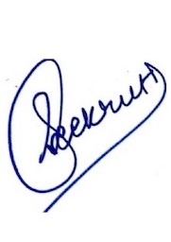

Survepalli Sreekruti

A2305220266

5CSE1Y (2020-24)

**certificate**

This is to certify that **Ms. Survepalli Sreekruti**, student of B. Tech in Computer Science & Engineering, has carried out work presented in the In-House Practical Training entitled “**Making Chatbot using Python**” as a part of her 5th year Program of Bachelor of Technology in Computer Science & Engineering from Amity University Noida,under my supervision.

I Dr. Juhi Singh

iDepartment of Computer Science & iEngineering

iASET

iNoida, Uttar Pradesh

**ACHNOWLEDGEMENT**

The completion of this project would be incomplete without the mention of people whose constant guidance has to be awarded with my success

I would like to express my deep and sincere gratitude to my research supervisor, **Dr Juhi Singh, Asst. Professor III, Amity University, Noida, Uttar Pradesh**, for giving me the opportunity to do research on topic **“Making Chatbot using Python”** and providing invaluable guidance throughout this research. It was a great privilege and honour to work and study under her guidance. I would like to thank him for solving my queries and also guide me through out.

**Abstract**

A chatbot is a computer program that can communicate with humans using AI in messaging platforms.

Just imagine how amazing it is to tell someone everything and anything and not being judged at all. It is a top class feeling and that’s what the beauty of a chatbot is.

As we all use Google Assistant, Google Assistant is actually an advanced version of a chatbot which is basically a computer program designed to establish conversation with humans over the internet. It is one of the most popular applications of Natural Language Processing, which is a subdomain of AI that deals with the communication between computers and humans using the natural language.

With the use of deep learning, I created a chatbot. The dataset that contains categories, patterns, and user-generated responses is used to train the chatbot. In order to determine which category the input message falls under, I utilised a special network called LSTM, a recurrent neural network. Next, we will choose a response from the list of options.

**index**

|  |  |  |
| --- | --- | --- |
| S. NO. | CONTENT | PAGE NO. |
| 1. | INTRODUCTION | 7-8 |
| 2. | LITERATURE SURVEY | 9-10 |
| 3. | METHODOLOGY | 11-12 |
| 4. | PROPOSED PYTHON CODE | 12-16 |
| 5. | RESULT & DISCUSSION | 16 |
| 6. | CONCLUSION | 17 |
| 7. | FUTURE WORK AND CHALLENGES | 17-18 |
| 8. | REFERENCES | 18 |

**Introduction**

A clever piece of software called a ‘Chatbot’ can converse and carry out tasks much like a human would. Chatbots are frequently used for customer service, instant messaging clients, and social media marketing. Based on how they are constructed, chatbot models can be divided into two categories:

**1.Retrieval Based Models**

**2.Generative Based Models**

**Retrieval Based Models-**

In this model, bots employ specified input and output patterns. Using methods like keyword matching, machine learning, or deep learning, they are taught to respond appropriately from a database of predeclared responses. They are mostly utilised in the business to create goal-oriented chatbots, where we can tailor the tone and flow of the bot and provide the greatest experience for our users.

**Generative Based Models-**

These models don't rely on predefined responses in any way. For multi-step training, these bots combine supervised learning, unsupervised learning, reinforcement learning, and adversarial learning. Here, we're converting an input into an output. It relies on Deep Neural Networks and requires a lot of data. Using this paradigm, the bits can create new conversations based on a significant amount of conversational training data.

I'm going to use deep learning to create a chatbot for my project.

Deep learning is a kind of machine learning that employs algorithms that mimic the neural networks and connections seen in the human brain.

Today, artificial intelligence (AI)-powered chatbots employ natural language processing (NLP) to comprehend text and voice commands from humans and gain knowledge from their experiences. For businesses and brands with a significant online presence, chatbots have established themselves as a standard tool for client contact.

Chatbots using python are a nifty tool since they facilitate instant messaging between the brand and the customer. Think about Apple’s Siri, Amazon’s Alexa, and Microsoft’s Cortana, which are the most popular chatbots used worldwide.

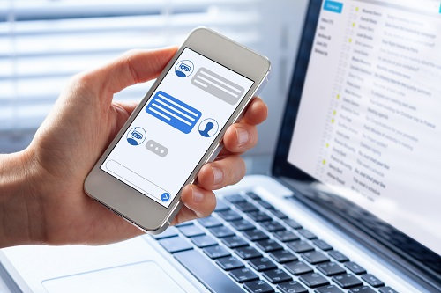

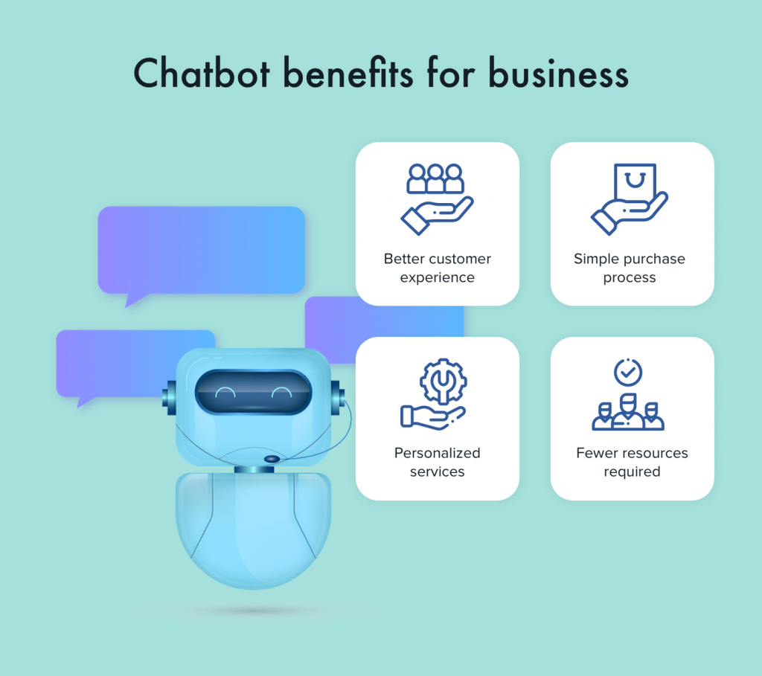 Since these bots can learn from behaviour and experiences, they respond to ia iwide irange of queries and commands.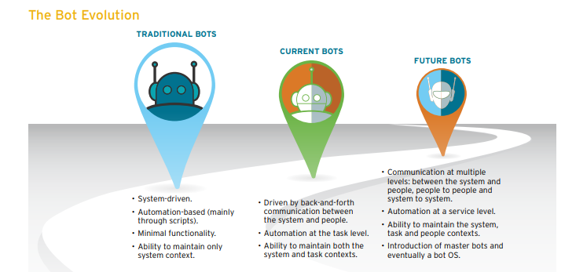Although chatbot in python has already begun to dominate the tech scene at present, Gartner predicts that by 2023, chatbots will control almost 85% of customer-brand interactactions.

**LITERATURE SURVEY**

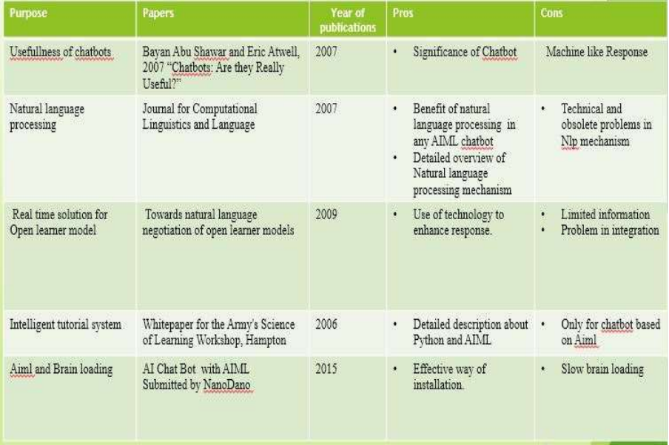

**Natural Language Processing-**

The science of teaching computers to understand our languages is known as natural language processing (NLP). Without NLP, computers may just view human language as a collection of meaningless symbols. Our language's vocabulary and syntax are not recognised by computers. NLP can also be referred to as a "Translator," converting spoken languages into information and language that computers can understand. In the past, using computers required people to correctly follow predetermined methods. Similar to Linux systems, all commands must be exact. However, the number of procedures has decreased when NLP entered the picture. Like, Apple's Siri and Microsoft's Cortana have revolutionised communication methods and made it feasible to provide commands in human languages.

**Machine Learning-**

Computers may now learn without being explicitly programmed thanks to the field of Machine Learning. Classification and regression are the two most typical uses of ML. Classification is the process of classifying various types of data, whereas regression is the process of explaining the data. The two steps of ML algorithms are always "fitting" and "predicting." The programme is provided with a sizable set of data during the fitting phase. In order to make the input data fit the model as closely as possible, the programme then tries to modify a parameter based on statistical models. The programme makes a prediction for a new input during the predicting step using the parameters it has calculated.

1.According to researches **“Chatbot Utilization for Medical Consultant System”**-

Chatbots can be applied to clinical benefits. The target of this work is to carry out the medical consultant system administration Chatbot Technology.

2.According to researches **“Deep Learning Techniques for Implementation of Chatbots”**–

Different methodologies for the advancement of chatbots and various innovations in the making of chatbots created in light of deep learning. NLTK is a module in python for Natural Language Processing. It is used to take input in the speech form and produce human understandable responses.

3. According to researches **“Creating and Evaluating Chatbots as Eligibility Assistants for Clinical Trials: An Active Deep Learning Approach towards User-centered Classification ''.**

4.According to the **“A iSurvey on Chatbot Implementation iin Customer Service Industry through iDeep Neural Network”.**

5.According to research **“A Rule based Approach to Word Lemmatization”**.

**METHODOLOGY**

Here are the 5 steps to create a chatbot in Python:

### **STEP 1**- **Connecting with Google Drive Files and Folders**

### The first step is to create a folder by the name 'ChatBot' in our Google drive. Then we upload the 'intents.json' file in this folder.

### **STEP 2**- **Importing Relevant Libraries**

The next step is to import the necessary python libraries.

### **STEP 3**- **Reading the JSON file**

### Now we load our data into Python. The dataset has an object called ‘intents’. Each intent has its own tag, context, patterns, and responses.

### **STEP 4**- **Identifying Feature and Target for the NLP Model**

I have extracted words from patterns and the corresponding tag to them. This has been achieved by iterating over each pattern using a nested for loop and tokenizing it using ntlk.word_tokeniser The words arestored in ‘data_X’ and the corresponding tag has been stored in ‘data_Y’**.** For the list words, the words have been converted into their root words using NLTK's WordNetLemmatizer(). This step saves us a lot of time when we will feed these words to our deep learning model. At last, both the lists have been sorted and duplicates have been removed.

### **STEP 5**- **Making the data Machine-friendly**

### Now we convert our text into numbers using the bag-of-words (bow) model. The two lists, ‘words’ and ‘classes’, act as a vocabulary for patterns and tags respectively. These are used to create an array of numbers with same length as that of vocabulary lists. The array has values as 1 if the word is present in the pattern/tag being read (from data_X) and 0 if it is absent. The data that is converted into numbers are stored in two arrays: train_X and train_Y where the ‘train_X’ denote features and ‘train_Y’ denote target variables.

### **STEP 6- Building the Neural Network Model**

Next, I created a neural network using Keras Sequential model. The input to this network is the array train_X. These would then move through the model's three layers, each of which had a layer with 128 neurons, a layer with 64 neurons, and a layer with exactly as many neurons as there were elements in train_Y. Next, I chose the Adam optimizer to reach the correct weights and defined the error function using the categorical cross-entropy function. To reach the desired accuracy I will train the chatbot 150 times.

### **STEP 7- Pre-processing the User’s Input**

### I will create some easy functions that will convert the user’s input to arrays and predict the corresponding tag to it. The code will then allow our machine to select one of the responses corresponding to that tag and show it as output.

### **STEP 8- Calling the Relevant Functions and interacting with the Chat Bot**

We now just have to take the input from ithe user and call the previously defined functions.

**Python code**

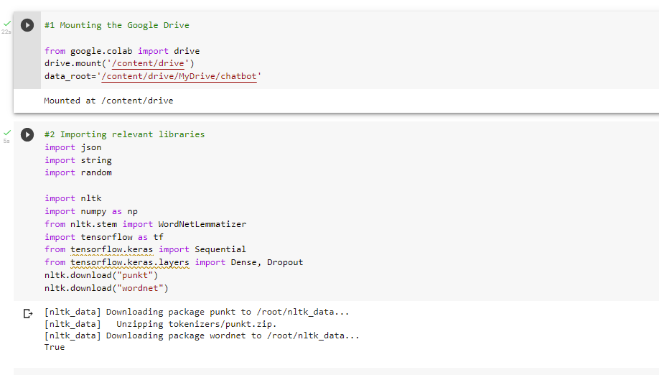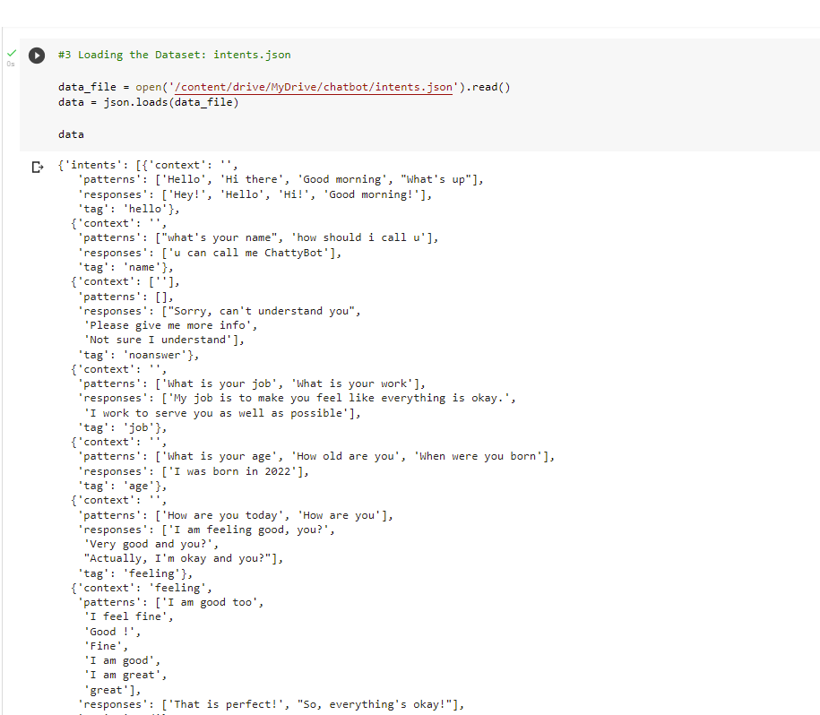

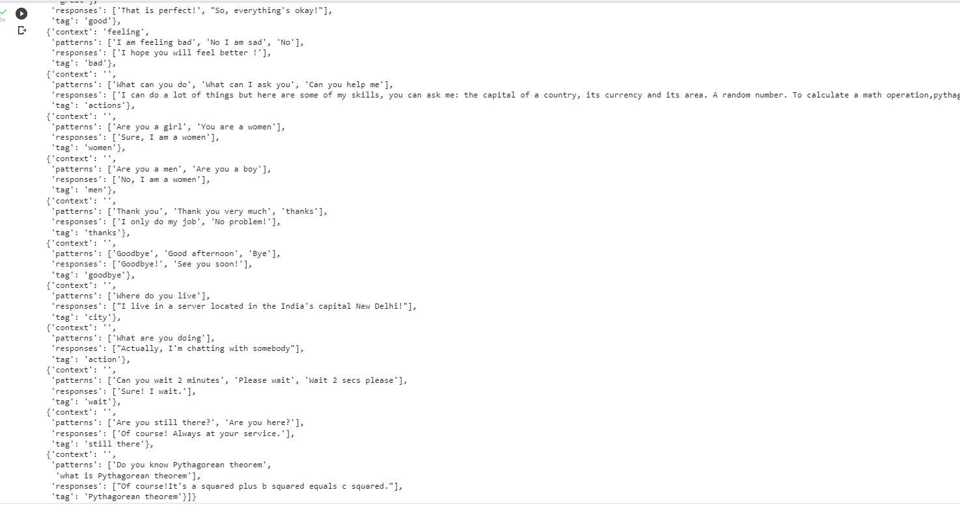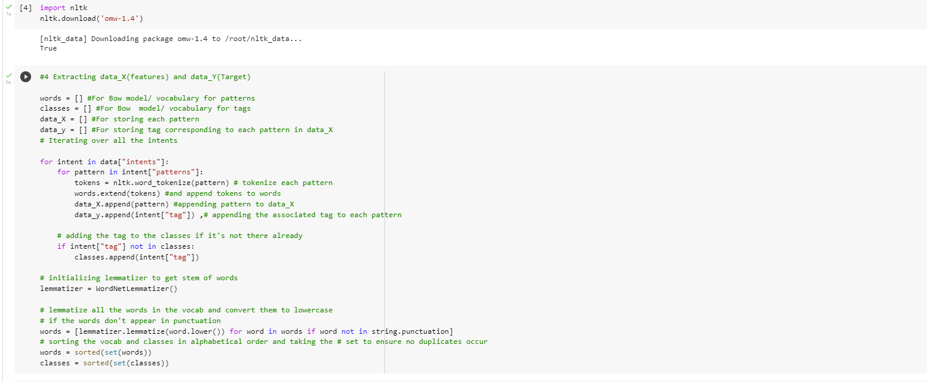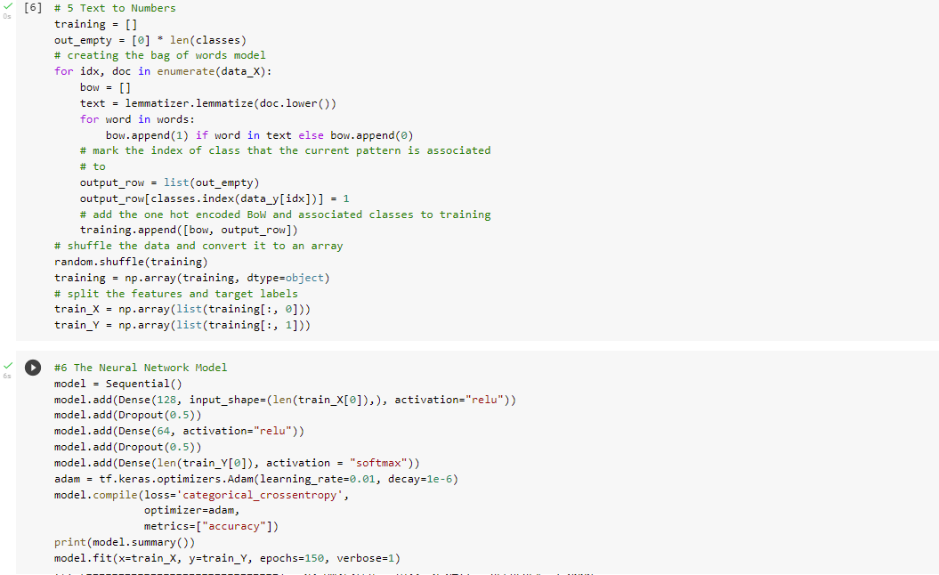

### 

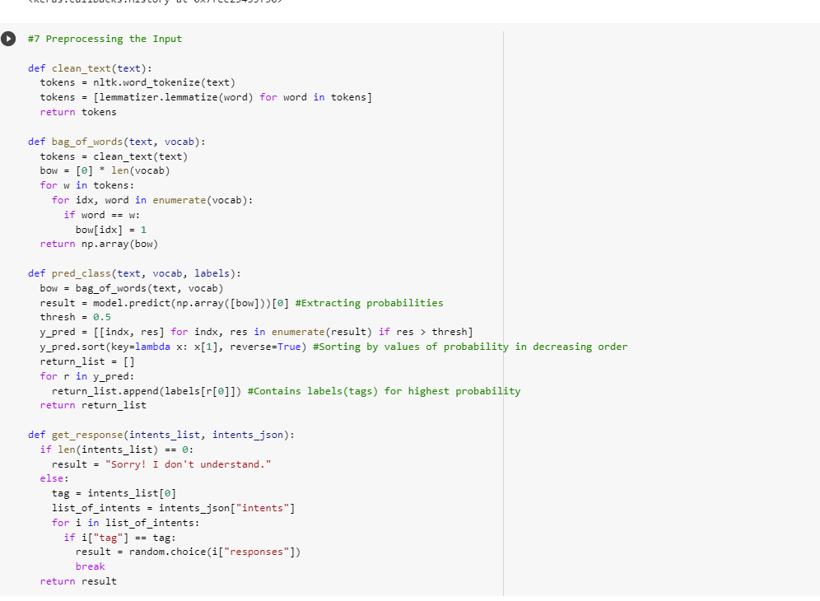

**iReSULT AND DISCUSSION**

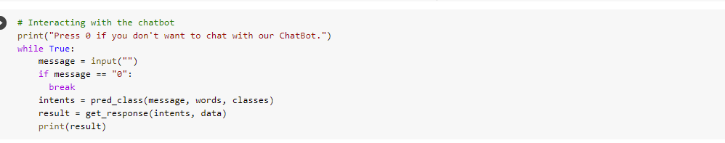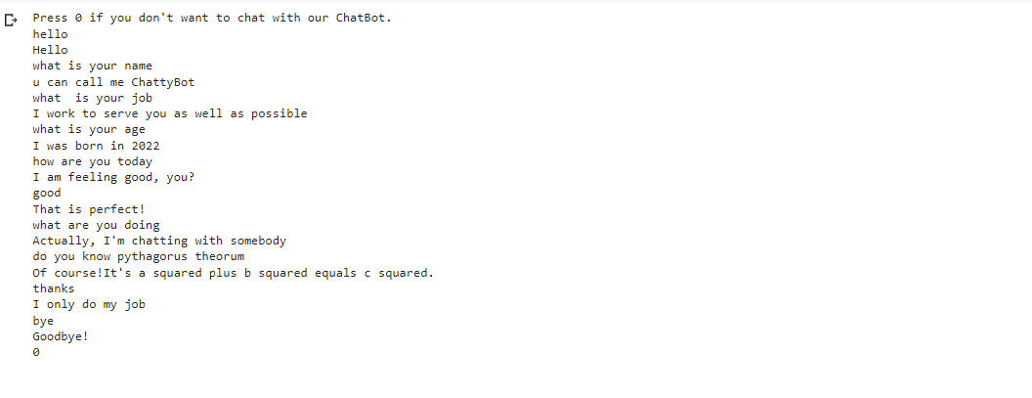

iThis is the simple chatbot which I created. We can add more responses and tags to our intents.js to make in more interactive.

**CONCLUSION**

In this Python data science project, we understood about chatbots and

implemented a deep learning version of a chatbot in Python which is accurate.

You can customize the data according to business requirements and train the

chatbot with great accuracy. Chatbots are used everywhere and all businesses

are looking forward to implementing bot in their workflow.

In this Python data science project, we understood about chatbots and

implemented a deep learning version of a chatbot in Python which is accurate.

You can customize the data according to business requirements and train the

chatbot with great accuracy. Chatbots are used everywhere and all businesses

are looking forward to implementing bot in their workflow.

In this Python data science project, we learned about chatbots and developed an accurate deep learning chatbot in Python.

### The data can be modified in accordance with organisational needs, and the chatbot can be trained very precisely. The use of chatbots is widespread, and every organisation is eager to integrate them into its daily operations.

### The new apps are chatbots. They are just concerned with supplying information and carrying out tasks for the people they communicate with.

**FUTURE WORK AND CHALLENGES**

In this Python data science project, we understood about chatbots and

implemented a deep learning version of a chatbot in Python which is accurate.

You can customize the data according to business requirements and train the

chatbot with great accuracy. Chatbots are used everywhere and all businesses

are looking forward to implementing bot in their workflow.

In this Python data science project, we understood about chatbots and

implemented a deep learning version of a chatbot in Python which is accurate.

You can customize the data according to business requirements and train the

chatbot with great accuracy. Chatbots are used everywhere and all businesses

are looking forward to implementing bot in their workflow.

There are a few drawbacks and challenges in the field.

Matters would have been better if we use self-learning models. But ithe ichallenge iwith ithese imodels is that they require a big training set that needs to be designed manually. So, that is why chatbots are usually kept to serve certain essential tasks, like handling office client complaints and interactions to a certain level and record their issues. However, they are developing at a very fast rate. We can imagine some evolved bots soon.

As further improvements we can try different tasks ito ibuild a chatbot with better performance and features:

1. **Use more data to train:** We can add more data to our training dataset. A ilarge idataset iwith imore inumber of intents which can lead to making a powerful chatbot.
2. **Apply different NLP techniques:** We can add more NLP solutions to your chatbot solution like Named Entity Recognition (NER) to add more features to your chatbot. With this feature we can easily find out any entity that appeared in user chat messages and use it for further conversations. We can also add a ‘**Sentiment Analysis**’ model to identify different sentiments behind user messages and it will exactly give some additional benefits to our chatbot.
3. **Try different neural network architectures:** We can also add idifferent ineural inetwork architectures with various hyperparameters.
4. **Add Html, CSS and emojis:** We can also build our models by adding html, CSS and emojis in the output phase to make it beautiful and attractive.

**REFERENCES**

<https://www.projectpro.io/article/python-chatbot-project-learn-to-build-a-chatbot-from-scratch/429> - Page 15,16

<https://www.researchgate.net/publication/358214948_Python_Chatbot_Project> - Page 7,8

<https://www.academia.edu/38409853/CHATBOT_IN_PYTHON> - Page 9,10

<https://data-flair.training/blogs/python-chatbot-project/> - Page 11,12,13

<https://www.edureka.co/blog/how-to-make-a-chatbot-in-python/> - Page 12,13

<https://www.warse.org/IJATCSE/static/pdf/file/ijatcse741032021.pdf-> Page 9,10